Introduction

The website design project requires the creation of a website which will be created for the client Amanda Elstob. The client is a hairdresser looking for a website to advertise a new business; mobile hairdressing service which she is setting up. The website is to give an insight into the business and to advertise the services that are provided. This website is to be targeted at all ages and both genders. Some of the services that the client offers are aimed at certain ages and the pages will be designed to suit the target audience.

The meeting for the website's design and requirements, which will be created for the client, happened on the 21th October 2012. As the client is in charge of all areas of the business, gathering the information needed for the website was undertaken at this meeting.
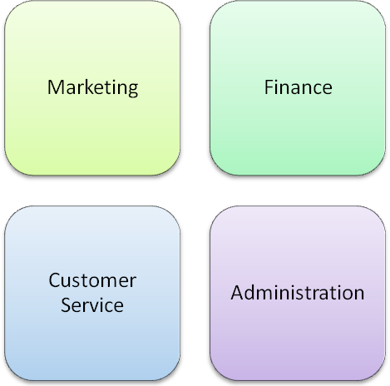

Project Review Form
